**1. Storing Data in a Table**

Use INSERT INTO to add data to tables

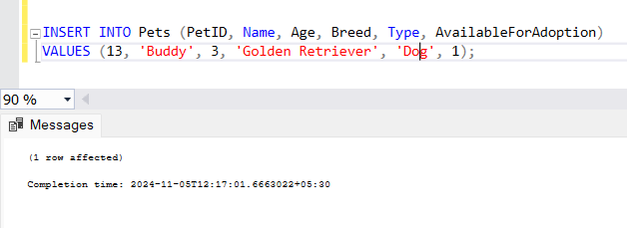

**2. Updating Data in a Table**

Use UPDATE to modify existing records.

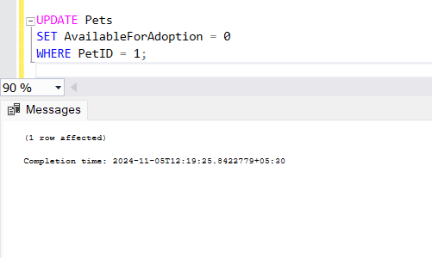

**3. Deleting Data from a Table**

Use DELETE FROM to remove records.

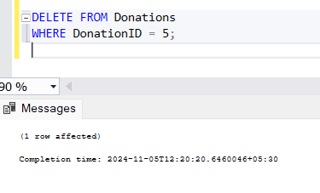

**4. Retrieving Specific Attributes**

Use SELECT to get specific columns from a table.

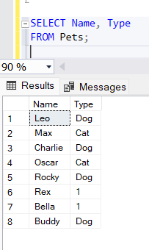

**5. Retrieving Selected Rows**

Use SELECT with conditions to filter rows.

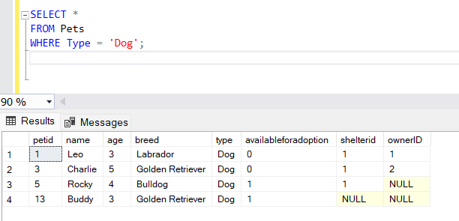

**6. Filtering Data: WHERE Clauses**

The WHERE clause is used to filter records based on conditions.

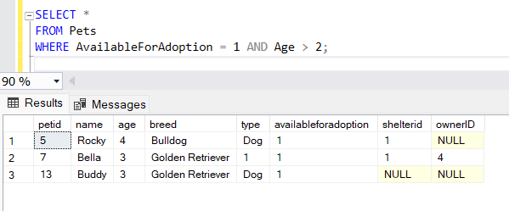

**7. Filtering Data: IN, DISTINCT, AND, OR, BETWEEN, LIKE**

**IN**: Use IN to match any value in a list.

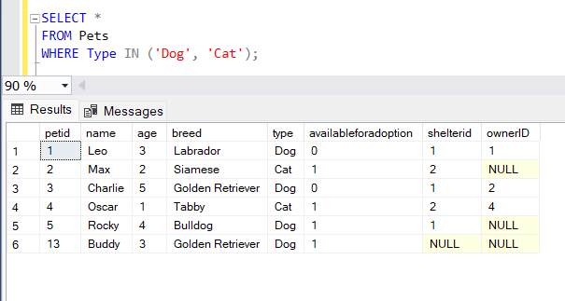

**DISTINCT**: Use DISTINCT to get unique values.

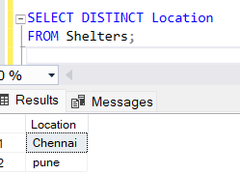

**AND / OR**: Combine conditions with AND or OR

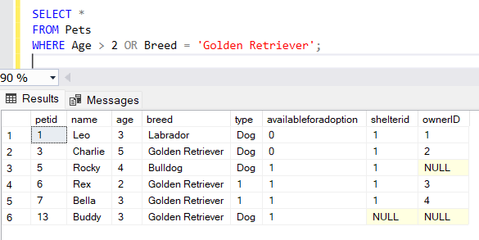

**BETWEEN**: Use BETWEEN to specify a range

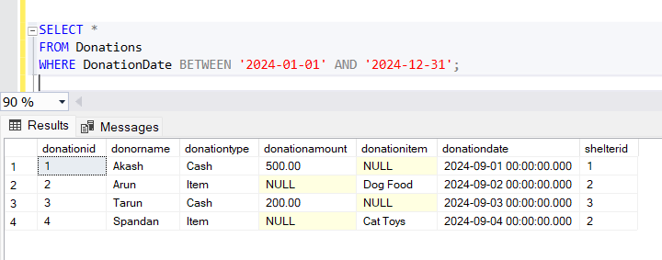

**LIKE**: Use LIKE for pattern matching.

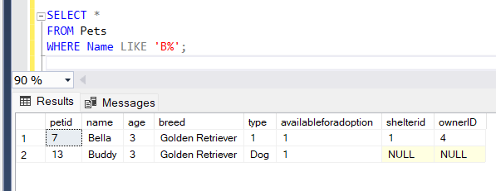

8. **Column and Table Aliases**

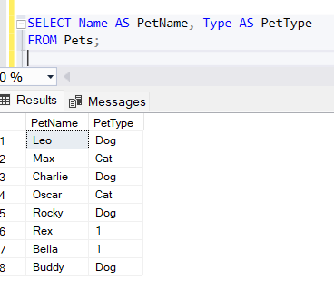

9. **Filtering Data using SQL Queries**

Retrieve pets available for adoption:

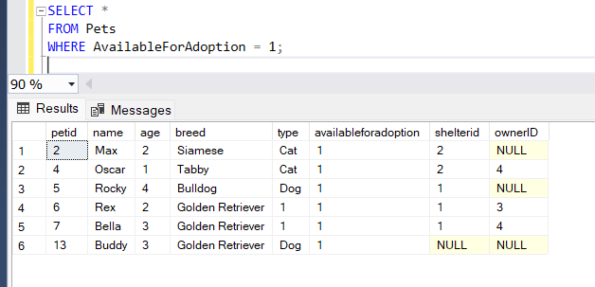

Retrieve donations of type "Cash" greater than 100:

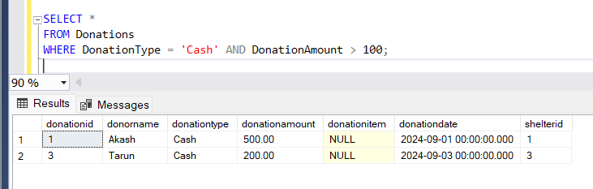

10. **Total Aggregations using SQL Queries**

Find the total number of pets:

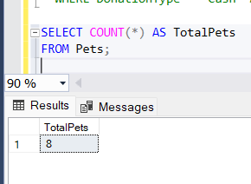

Calculate the total cash donations: 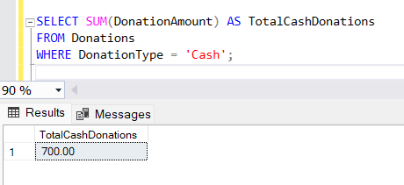

Find the average age of pets:

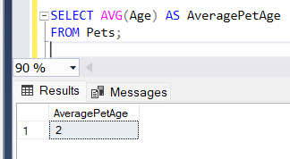

11. **Group By Aggregations using SQL Queries**

Find the count of pets by type:

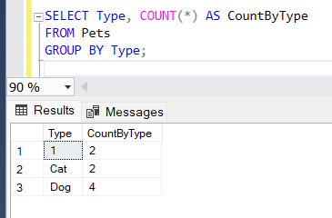

Find the total donations per donor

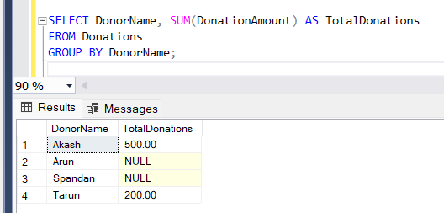

12. **Rules and Restrictions to Group and Filter Data in SQL Queries**

Get the count of pets of each type but only show types with more than 1 pet

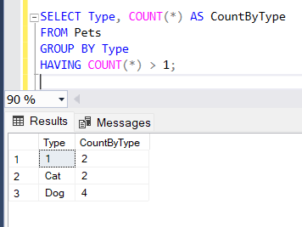

13. **Filter Data based on Aggregated Results using Group By and Having**

Retrieve each shelter that has received more than $500 in cash donations

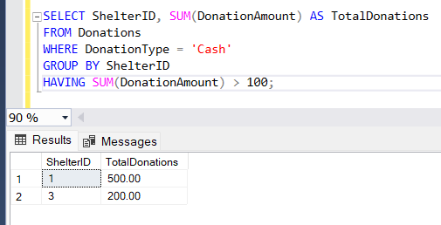

Get the types of pets with an average age of over 2 years:

